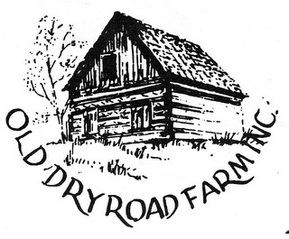

APPLICATION FOR MEMBERSHIP
Old Dry Road Farm is a 501(c)(3) Non-profit Corporation
Please complete form, detach, and send with dues to:
Old Dry Road Farm
P.0. Box 163
Wernersville, PA 19565

Name

Address

Phone (h) (c)
Email:

[ ] Student $1.00 [ ] Contributing $25.00
[ ] Individual $5.00 [ ] Benefactor $100.00
[ ] Sustaining $10.00 [ ] Business $50.00

